

Technology Management

Assignment 2

Section A

Zaid Mustafa

22-10249

Waqas Rasheed

22-11004

Hatib Zubair

241547206

Practice Scenario 1 2

Monitoring and Event Management 2

Practice Scenario 2 5

Availability Management 5

# Practice Scenario 1

## Monitoring and Event Management

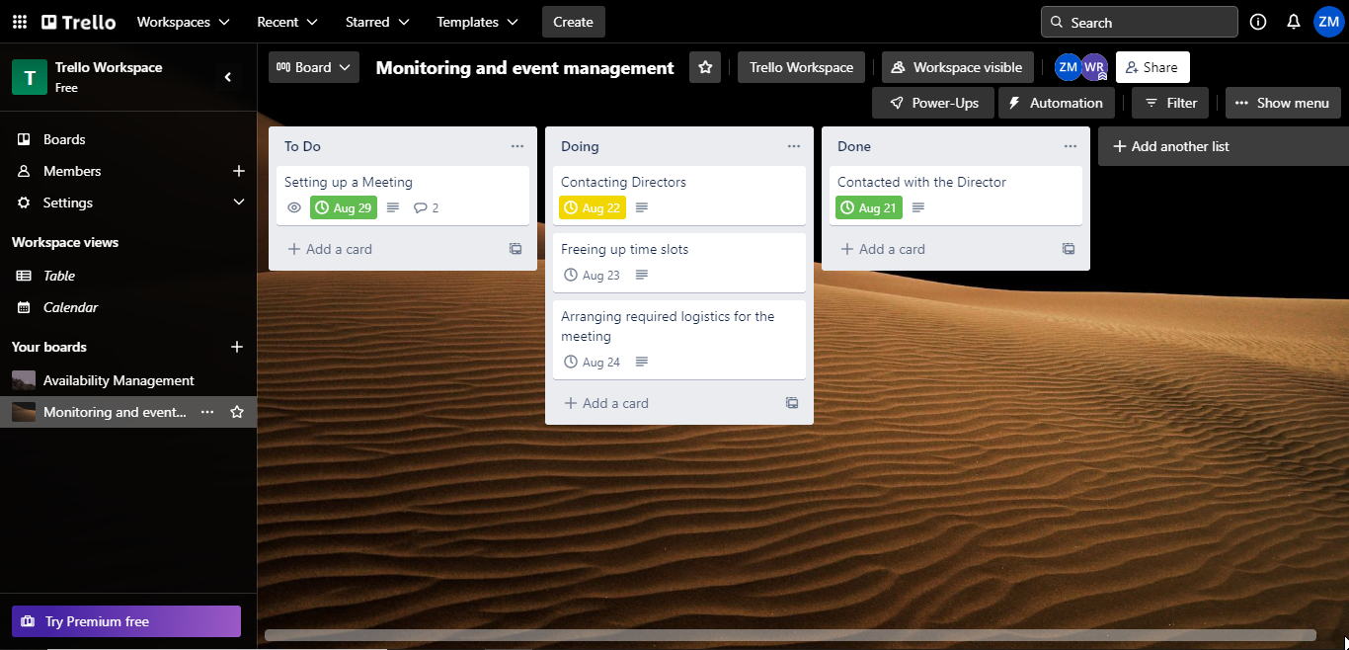

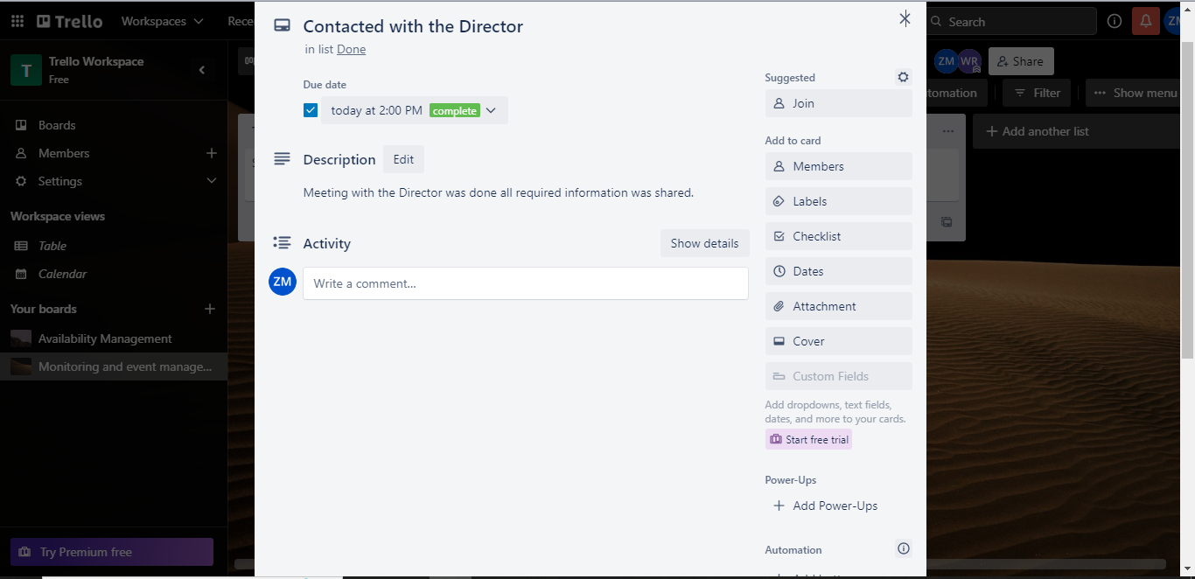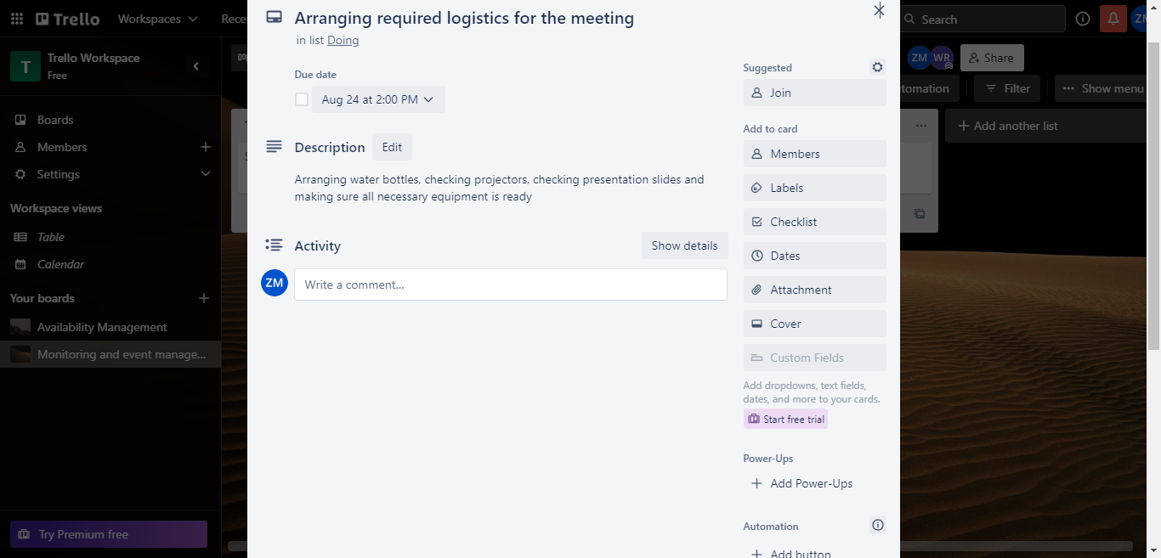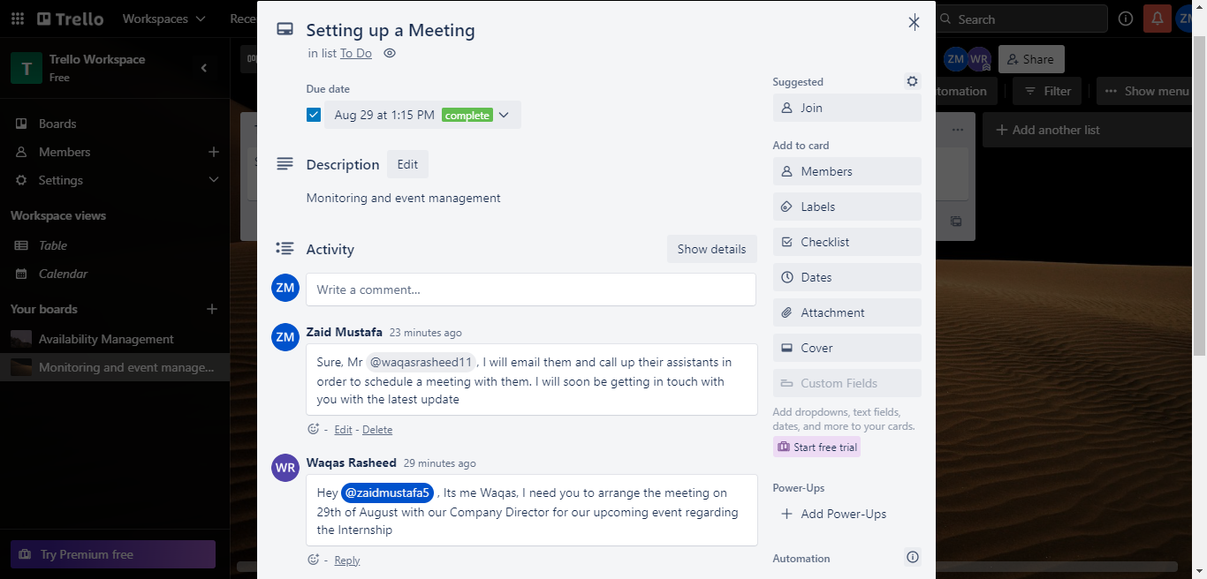

# Practice Scenario 2

## Availability Management

